Picture of wave number w.s.t. time for different location (x2,x18,x37,x56,x75)

(black, blue,green, red, brown)

When simply replace NA by 0, we have the following plot across time.

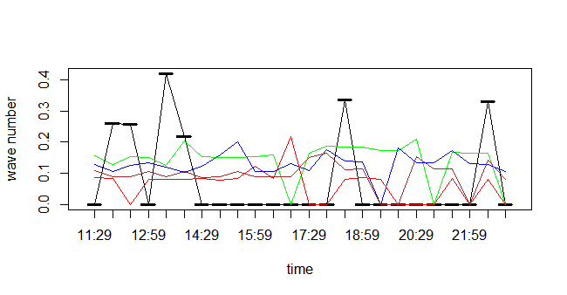

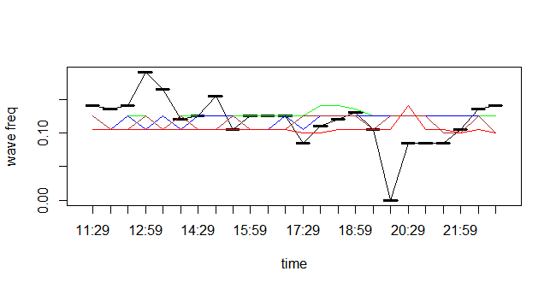

But the problem is we have too many missing values.

Quick classification of missing data

There are two types of missing data:

* MCAR: missing completely at random. This is the desirable scenario in [case](http://rover.ebay.com/rover/13/0/19/DealFrame/DealFrame.cmp?bm=262&BEFID=93768&acode=259&code=259&aon=&crawler_id=521273&dealId=tNy_VBtILm-z0eNqwcHQtQ%3D%3D&searchID=&url=https%3A%2F%2Fwww.shoemall.com%2Fproduct%2Fanna-by-anuschka-smart-phone-case-wallet%2F1070985-3%3Futm_source%3DShoppingCPA2%26utm_medium%3DCSE%26utm_campaign%3DCSE%26CAWELAID%3D330007400007388805%26mid%3D521273%26sdc_id%3D%7Bsdc_id%7D&DealName=Anna%20by%20Anuschka%20Smart%20Phone%20Case%20%26%20Wallet%20Multi%20Misc%20Accessories%20No%20Size&MerchantID=521273&HasLink=yes&category=0&AR=-1&NG=1&GR=1&ND=1&PN=1&RR=-1&ST=&MN=msnFeed&FPT=SDCF&NDS=1&NMS=1&NDP=1&MRS=&PD=0&brnId=2455&lnkId=8070676&Issdt=170719051332&IsFtr=0&IsSmart=0&dlprc=81.95&SKU=538460BUT) of missing data.
* MNAR: missing not at random. Missing not at random data is a more serious issue and in this [case](http://rover.ebay.com/rover/13/0/19/DealFrame/DealFrame.cmp?bm=262&BEFID=93768&acode=259&code=259&aon=&crawler_id=521273&dealId=tNy_VBtILm-z0eNqwcHQtQ%3D%3D&searchID=&url=https%3A%2F%2Fwww.shoemall.com%2Fproduct%2Fanna-by-anuschka-smart-phone-case-wallet%2F1070985-3%3Futm_source%3DShoppingCPA2%26utm_medium%3DCSE%26utm_campaign%3DCSE%26CAWELAID%3D330007400007388805%26mid%3D521273%26sdc_id%3D%7Bsdc_id%7D&DealName=Anna%20by%20Anuschka%20Smart%20Phone%20Case%20%26%20Wallet%20Multi%20Misc%20Accessories%20No%20Size&MerchantID=521273&HasLink=yes&category=0&AR=-1&NG=1&GR=1&ND=1&PN=1&RR=-1&ST=&MN=msnFeed&FPT=SDCF&NDS=1&NMS=1&NDP=1&MRS=&PD=0&brnId=2455&lnkId=8070676&Issdt=170719051332&IsFtr=0&IsSmart=0&dlprc=81.95&SKU=538460BUT) it might be wise to check the data gathering process further and try to understand why the information is missing. For instance, if most of the people in a survey did not answer a certain question, why did they do that? Was the question unclear?

And there’re two ways to fix this problem:

1. Nearest neighborhood estimate
2. EM algorithm

After using the nearest neighborhood estimate by taking average of the two nearest spot, we have the following graphs.